1 Answer these questions before you watch the video:

1. How do you think we can achieve success in life?

Doing the things you like is the best thing you can do

1. Do you consider academic life the best way for a promising future?

No, because if you that your product is going to work it is wasting time

2 Do you agree or disagree: *“We learn when we fail.”* Comment on this sentence.

You will trip over the same stone several times but little by little you will go further

3 Using the help of a dictionary find these meanings:

Big Deal__________Vaya cosa________

Dots____Puntos____________

Dropped Out _____Abandono______

Drop In ___Entrar en un momento___

Quit _______renunciar_______

Unwed______Soltera_________

Popped Out ___aparecer______

Relented______cedido/cedida_______

Naively______Ingenuamente________

College Tuition __Matricula universitaria____

Figure it Out____Darse cuenta de

Pretty Scary___Bastante aterrador___

Stumbled________Tropezó_________

Gut______________Intestino_____

Fired______Despedido/Despedida____

Falling out_______Caerse______

Settle_____asentar________

4 After watching the video, answer these questions:

C) How do you join the dots of your life?  
Do what you like the most

D) How does Steve get his dots joined?

Get fired from your company

E) What single word would describe his life experience?

Creative

F) What does “death” mean to you, today?

Right now, it's losing everything you've done and you don't know what will happen after your death.

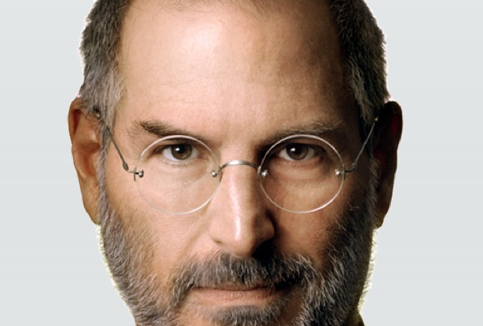

**Write the correct letter in the gaps of the right answer. There are more options than you need.**

A. ….. college

B. ….. the Internet in our

C. …..2020

D. ….. formed his own

E. ….. to deal with the new

F. ….. the scale of Thomas Edison

G. ….. of fifty-six

H. …..computer mouse

I. ….. his longtime friend

J. …..iPad

K. ..… Steve Wozniak

L. ….. revolutionized

M. …..bought

N. ….. that was in bad shape

O. …… successful companies

P. ….. at a tech leader

Steve Jobs made technology fun. The co-founder of Apple died last Wednesday at the age ___G_____. He had fought for years against cancer. Mourners gathered outside his house in Palo Alto, California, and Apple stores around the world.

Tim Bajarin is president of Creative Strategies, a high-tech research and consulting company. TIM BAJARIN: "If you actually look ____P___, they’re really happy if they have one hit in their life. Steve Jobs has the Apple II, the Mac, the iPod, the iPhone, the iPad and Pixar.”

Steve Jobs was a ____A__ dropout. He was adopted by a machinist and his wife, an accountant. They supported his early interest in electronics. He and his friend ___K__ started Apple Computer -- now just called Apple -- in nineteen seventy-six. They stayed at the company until nineteen eighty-five. That year, Steve Wozniak returned to college and Steve Jobs left in a dispute with the chief executive.

Mr. Jobs then ___D___ company, called NeXT Computer. He rejoined Apple in nineteen ninety-seven after it bought NeXT. He helped remake Apple from a business _____N___ then to one of the most valuable companies in the world today.

Steve Wozniak, speaking on CNN, remembered ___I___ as a "great visionary and leader" and a "marketing genius."

President Obama said in a statement: "By building one of the planet’s most __O___ from his garage, he exemplified the spirit of American ingenuity. By making computers personal and putting ___B__ pockets, he made the information revolution not only accessible, but intuitive and fun."

David Carroll is a professor at Parsons School of Design in New York City. He says Steve Jobs not only revolutionized technology, he also __L__ American business.

DAVID CARROLL: “The fact that he was able to redesign American commerce top to bottom and across is really stunning. He probably will be considered an industrial giant on ___F__ and Henry Ford, so one of the great of all time.” Steve Jobs stepped down as Apple's chief executive in August because of his health.

Apple's new chief, Tim Cook, will also have __E___ Kindle Fire tablet computer from Amazon.com. It costs less than half as much as an iPad but also does less.







1. Steve Jobs is going to tell three stories from his life. What is the first story about?

It is about the connecting the dots

1. Why did his mother decide to put him up for adoption?

Because she was a young unmarried a college graduate student

1. Why wasn’t he finally adopted by the lawyer and his wife?

They decided at the last minute that they wanted a girl

1. Why did his mother refuse to sign the adoption papers?

Because the adoptive parents were not college graduates

1. How long had he been at Reed College before he quit?

He had been at reed college for 6 months before he quit

1. Why did he drop out?

He felt he was wasting his parents savings

1. What did he do as soon as he dropped out?

He began dropping in on the classes that looked interesting

1. How did he get by?

He slept on the floor in friends rooms, he bought food with the money he received from returning cake bottles and he had one free meal a week at a hare krishna temple

1. In what way did the calligraphy class come in useful for him?

He applied this knowledge to the typography of the first macintosh computer, which he designed ten years later

1. Why is it important to believe that the dots will connect in the future?

Because it will give you the confidence to follow your heart even it leads you off the well-worn path

1. What is the third story about?

It is about death

1. What question has he asked himself every morning for the past 33 years?

If today were the last day of my life, would I want to do what I am about to do today

1. What is the most important tool that has helped him make the big choices in life?

Remembering that I´ll be dead soon

1. What type of cancer was he diagnosed with?

He was diagnosed with pancreatic cancer

1. How long did the doctors say he should expect to live?

No longer than three to six months

1. What did his doctor advise him to do?

To go home and get his affairs in order

1. Taking into consideration that our time is limited, what does he advise his college audience is the most important thing to do?

To have the courage to follow their heart and intuition

1. What was on the back cover of The Whole Earth Catalog final issue?

There was a photograph of an early morning country road and beneath it were the words “Stay Hungry. Stay Foolish

1. What is the second story about?

It is about love and loss

1. When and where did he start Apple?

He and his partner started Apple in His parents garage when he was 20

1. How much was Apple worth ten years later?

2 Billion

1. How many employees did it have?

Over 4000

1. Why was he fired from Apple? How did he feel?

He fell out with the person he ran the compay with, and the board of directors sided with the person. Steve was devastated

1. What helped him start again?

The fact that he still loved what he did

1. What was the first computer animated feature film?

Toy Story

1. How did he return to Apple?

He returned to Apple when Apple bought his company NeXT

1. What is the only way to be truly satisfied?

The only way to be truly satisfied is to love what you do

